*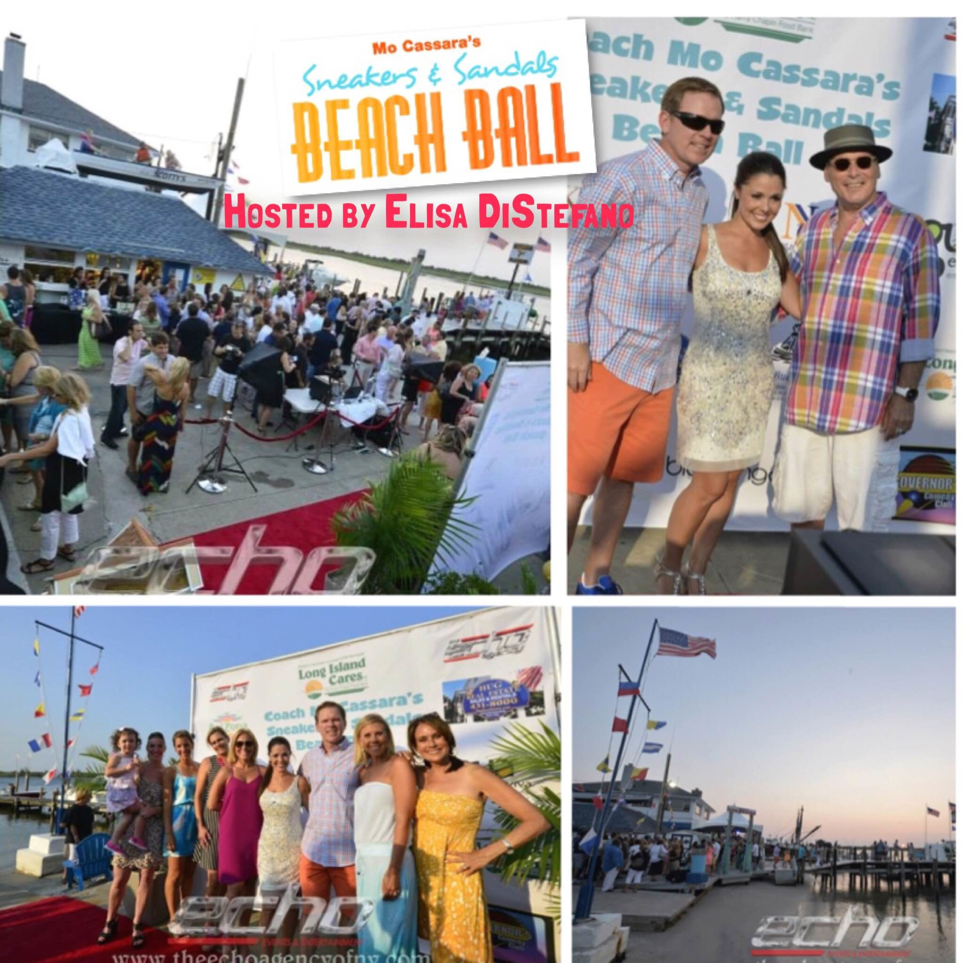*



*to benefit*

**

Sponsorship Opportunities

$2,500 (three sponsorships available)

* 10 Tickets – bring your entire staff!
* Company name and logo on red carpet step and repeat
* Company name and logo on promotional material and banners at event (you provide)
* Vendor space or promotional placement at event
* Opportunity to include choice item for gift bags
* Group photo with Sneakers and Sandals team on red carpet

$1,000 (ten sponsorships available)

* 4 Tickets
* Secondary placement of company name and logo on red carpet step and repeat
* Company name and logo on promotional material and banners at event (you provide)
* Opportunity to include choice item for gift bags

$500 (unlimited available)

* 2 Tickets
* Company name and logo on promotional material and banners at event (you provide)
* Opportunity to include choice item in gift bag  
    
    
  For more information or questions, please contact Cheryl Steinhauer at   
  Long Island Cares -- [csteinhauer@licares.org](mailto:csteinhauer@licares.org) or 631-582-3663 Ext. 104.  
  Long Island Cares, Inc., 10 Davids Drive, Hauppauge, NY 11788